Define the formal definition of nondeterministic finite automation (NFA)

An NFA is a finite automation with a 5-tuple where

1. Q is a finite set called the set of states
2. Epsilon is a finite set called the alphabet
3. S: Q x sigma -> P(Q) is the transition function
4. Q0 within Q is the start state
5. F <= Q is the set of accept states, also called the final states.

FROM SLIDE 124^^^

Explain clearly all the steps in converting NFA to DFA

To start, we will with the original NFA

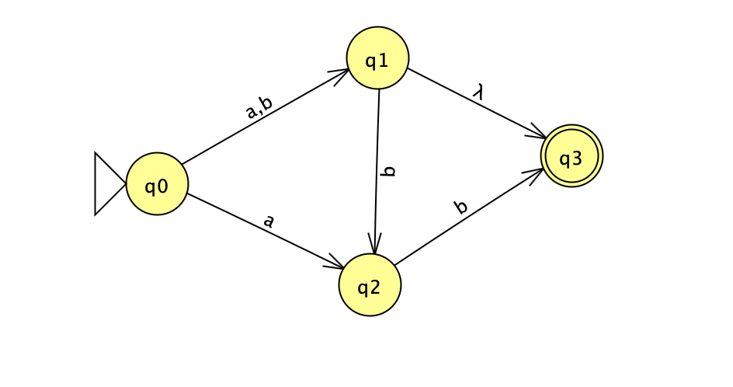then, we will go to Convert->Convert to DFA->Complete->Done

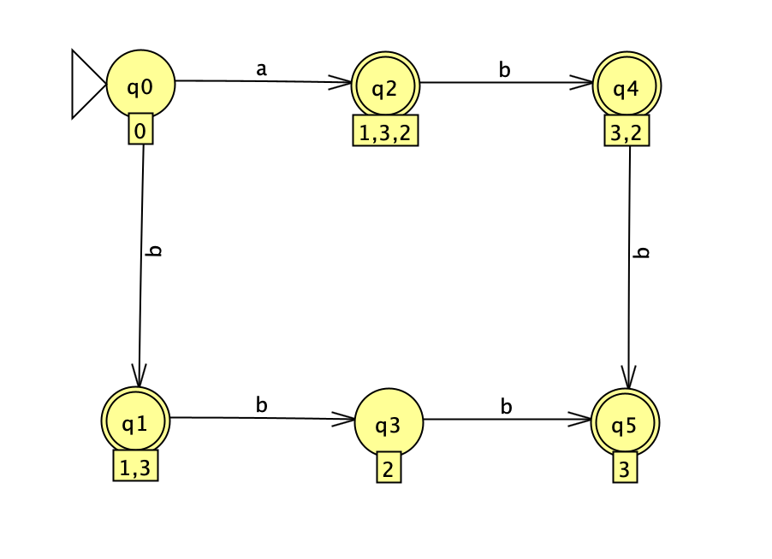

To convert to regex

Q0 = ebsilon -> 1

Q1 = Q0b -> 2

Q2 = Q0a -> 3

Q3 = Q1b -> 4

Q4 = Q2b -> 5

Q5 = Q3b + Q4b -> 6

Q5 = Q3b + Q4b

Substitute

Q5 = Q1bb + Q2bb

R R P R P

Q5 = (bb + bb)\*

To prove, lets prove using contradiction

aP bP where P = 3

Suppose that x = aa, y = a, and z = bbb

zyIz is accepted by M for any i >= 0

|y| > 0

|xy| <= P